Instructions
BookWise Solutions is a small and easy-to-use library program. Before starting, make sure Python is installed on your computer. Open this folder in VS Code or a terminal, and run the program by typing `python task.py`. Once it starts, you can add books, magazines, and DVDs, then borrow, return, or renew them when needed. The program saves your library information automatically, so you do not lose it when you close the program. When you are finished, simply choose the exit option from the menu.
Program Output

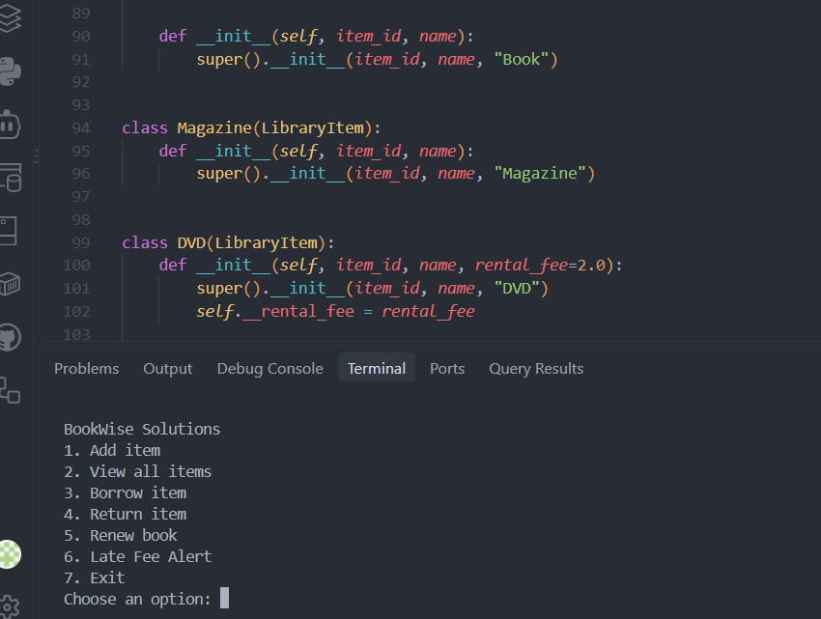

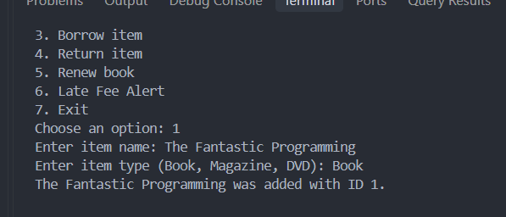
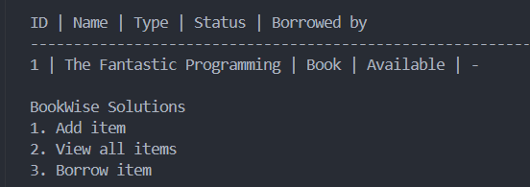

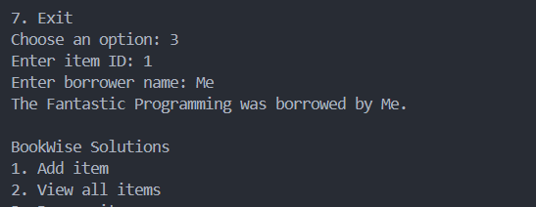

Class Diagram
